netcdf (for reading in nc)

Creating/opening netCDF

To create a netCDF file from python, you simply call the [Dataset](https://unidata.github.io/netcdf4-python/#Dataset) constructor. This is also the method used to open an existing netCDF file. If the file is open for write access (mode='w', 'r+' or 'a'), you may write any type of data including new dimensions, groups, variables and attributes. 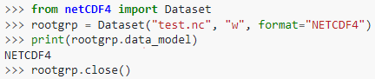

Groups

To create [Group](https://unidata.github.io/netcdf4-python/#Group) instances, use the [Dataset.createGroup](https://unidata.github.io/netcdf4-python/#Dataset.createGroup) method of a [Dataset](https://unidata.github.io/netcdf4-python/#Dataset) or [Group](https://unidata.github.io/netcdf4-python/#Group) instance. [Dataset.createGroup](https://unidata.github.io/netcdf4-python/#Dataset.createGroup) takes a single argument, a python string containing the name of the new group. The new [Group](https://unidata.github.io/netcdf4-python/#Group) instances contained within the root group can be accessed by name using the groups dictionary attribute of the [Dataset](https://unidata.github.io/netcdf4-python/#Dataset) instance. 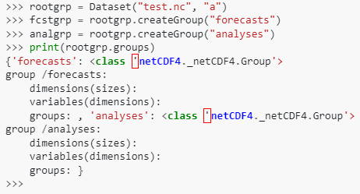

Dimensions

A dimension is created using the [Dataset.createDimension](https://unidata.github.io/netcdf4-python/#Dataset.createDimension) method of a [Dataset](https://unidata.github.io/netcdf4-python/#Dataset) or [Group](https://unidata.github.io/netcdf4-python/#Group) instance. A Python string is used to set the name of the dimension, and an integer value is used to set the size. To create an unlimited dimension (a dimension that can be appended to), the size value is set to None or 0. 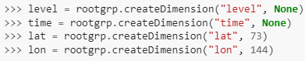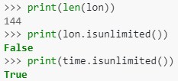

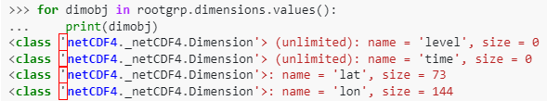

Variables

To create a netCDF variable, use the [Dataset.createVariable](https://unidata.github.io/netcdf4-python/#Dataset.createVariable) method of a [Dataset](https://unidata.github.io/netcdf4-python/#Dataset) or [Group](https://unidata.github.io/netcdf4-python/#Group) instance. The [Dataset.createVariable](https://unidata.github.io/netcdf4-python/#Dataset.createVariable)j method has two mandatory arguments, the variable name (a Python string), and the variable datatype. The variable's dimensions are given by a tuple containing the dimension names (defined previously with [Dataset.createDimension](https://unidata.github.io/netcdf4-python/#Dataset.createDimension)). To create a scalar variable, simply leave out the dimensions keyword.

Valid datatype specifiers include: 'f4' (32-bit floating point), 'f8' (64-bit floating point), 'i4' (32-bit signed integer), 'i2' (16-bit signed integer), 'i8' (64-bit signed integer), 'i1' (8-bit signed integer), 'u1' (8-bit unsigned integer), 'u2' (16-bit unsigned integer), 'u4' (32-bit unsigned integer), 'u8' (64-bit unsigned integer), or 'S1' (single-character string). 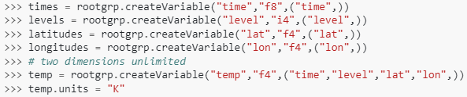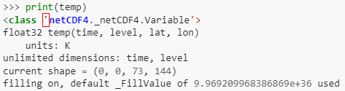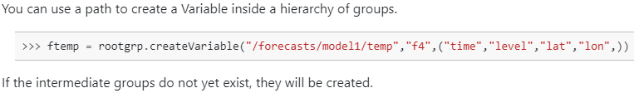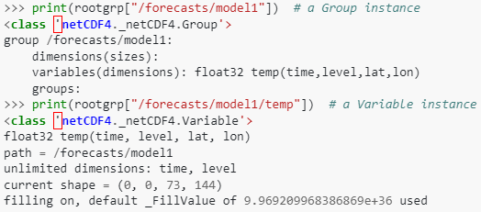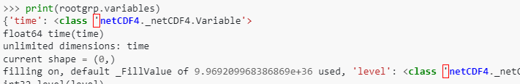

Attributes

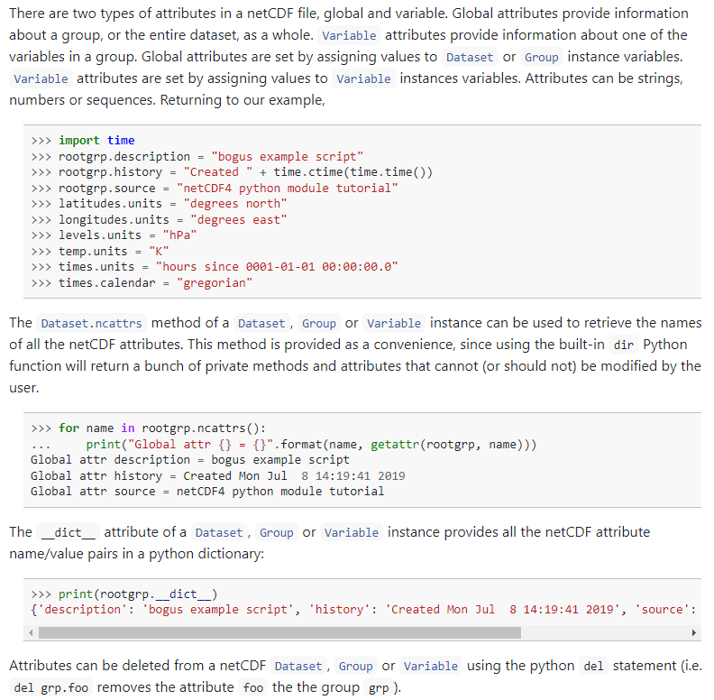

Writing and retrieving data

Simple data adding

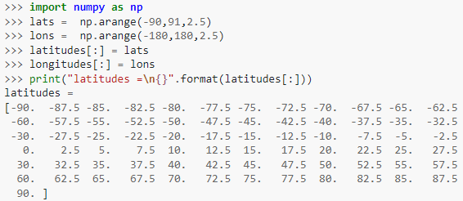

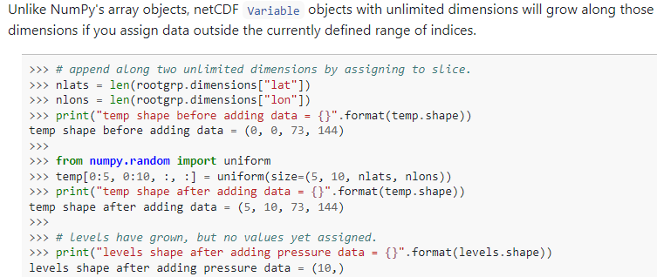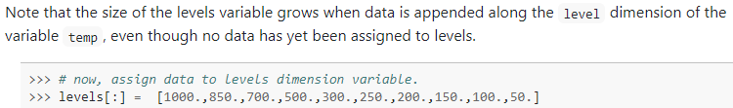

More details online

Time coordinates

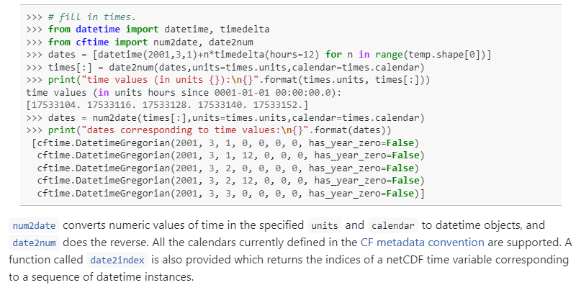

Multi-file dataset

You can use the [MFDataset](https://unidata.github.io/netcdf4-python/#MFDataset) class to read the data as if it were contained in a single file. Instead of using a single filename to create a [Dataset](https://unidata.github.io/netcdf4-python/#Dataset) instance, create a [MFDataset](https://unidata.github.io/netcdf4-python/#MFDataset) instance with either a list of filenames, or a string with a wildcard (which is then converted to a sorted list of files using the python glob module). Variables in the list of files that share the same unlimited dimension are aggregated together, and can be sliced across multiple files. 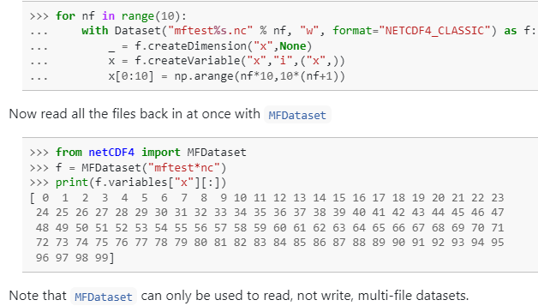

See [netCDF4 API documentation (unidata.github.io)](https://unidata.github.io/netcdf4-python/#creatingopeningclosing-a-netcdf-file) for a list of functions/methods in the netcdf library.

ALL INFORMATION IS FROM THE SOURCE BELOW:

*NETCDF4*. netCDF4 API documentation. (n.d.). Retrieved May 17, 2022, from https://unidata.github.io/netcdf4-python/#creatingopeningclosing-a-netcdf-file